ITCS 254: Introduction to Linux, Shell, and Commands
Lab 10 – Manipulating Text
- [From Lab9] Create an empty file named test.txt and check its permissions.
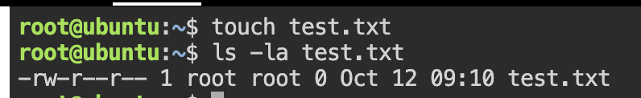
- [From Lab9] Change bob to be the owner and dev2 to be the group owner of test.txt
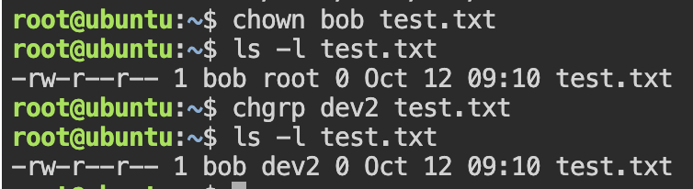
- [From Lab9] Change permission of test.txt to be rwxrw-r-- by numeric mode and display output.
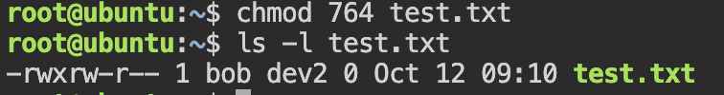
- [From Lab9] Change permission of test.txt to be rw-rw-rw- by symbolic mode and display output.
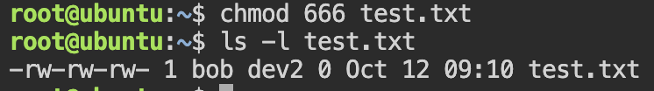
- Cat practices: http://linuxfoundation.s3-website-us-east-1.amazonaws.com/TIY/usingcat/index.html
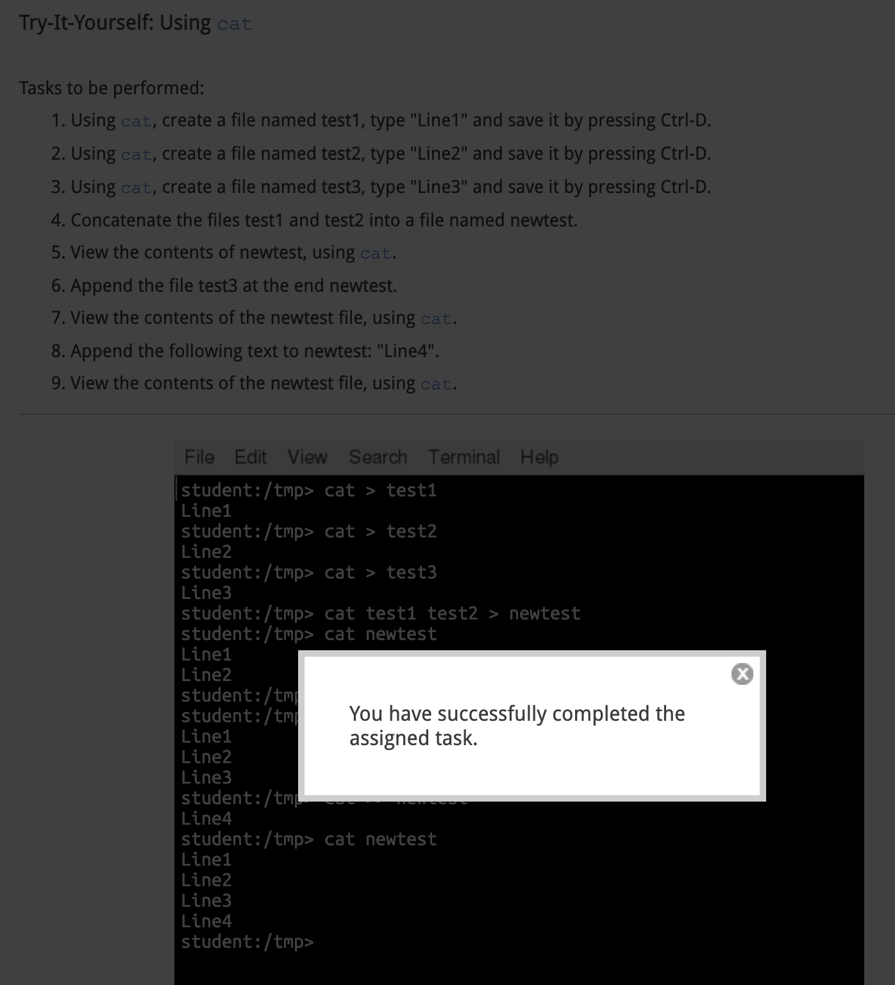

- Using sed
  - Create a text file containing:
This is a first line
This is a second line
This is a third line
  - Use sed command to replace “is” with “was” in line 1 – 2.
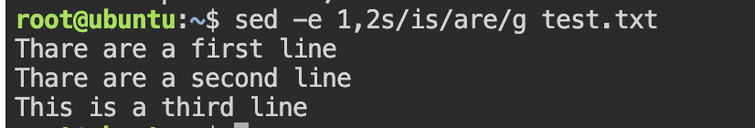
  - Use sed command to replace “a” with “the” for the whole text file and save it to another file.
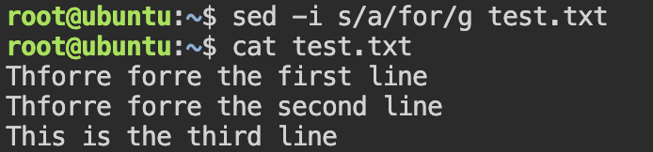
- Search for all instances of the user command interpreter (shell) equal to /sbin/nologin in /etc/passwd and replace them with /bin/bash (do not overwrite /etc/passwd).

- Do the following
  - Create a text file named planets containing:
Mercury
Mars
Earth
Neptune
Earth
Venus
Mercury
  - Count the number of lines in the file
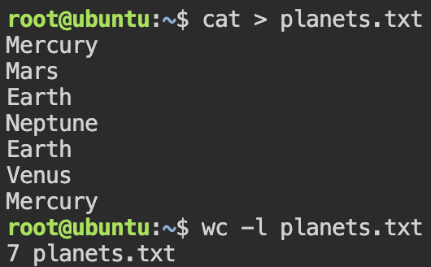
  - Sort the planets file
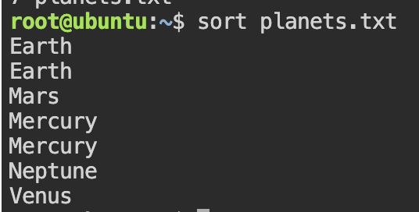
  - Remove duplicate entries from the planets file
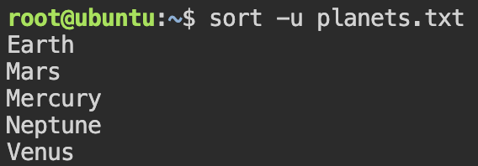
- Grep practice
  - Search for your username in file /etc/passwd.
  - Find all entries in /etc/services that include the string f‌‌tp.
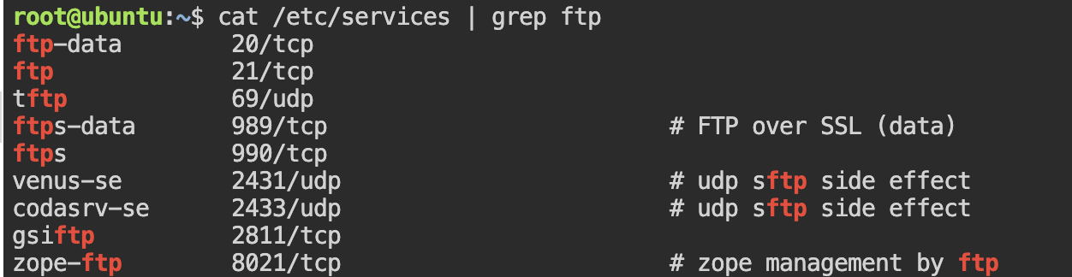
  - Restrict to those that use the tcp protocol.
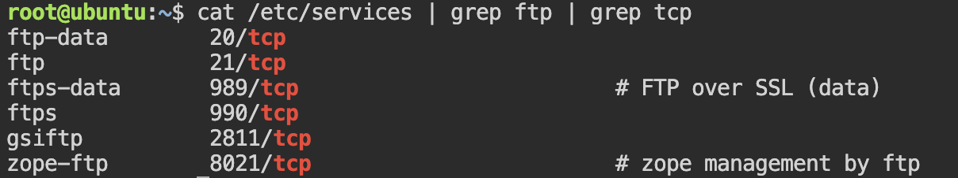
  - Get all strings that start with ts or end with st (use -e option for regular expression)
- Tr: http://linuxfoundation.s3-website-us-east-1.amazonaws.com/TIY/usingtr/index.html
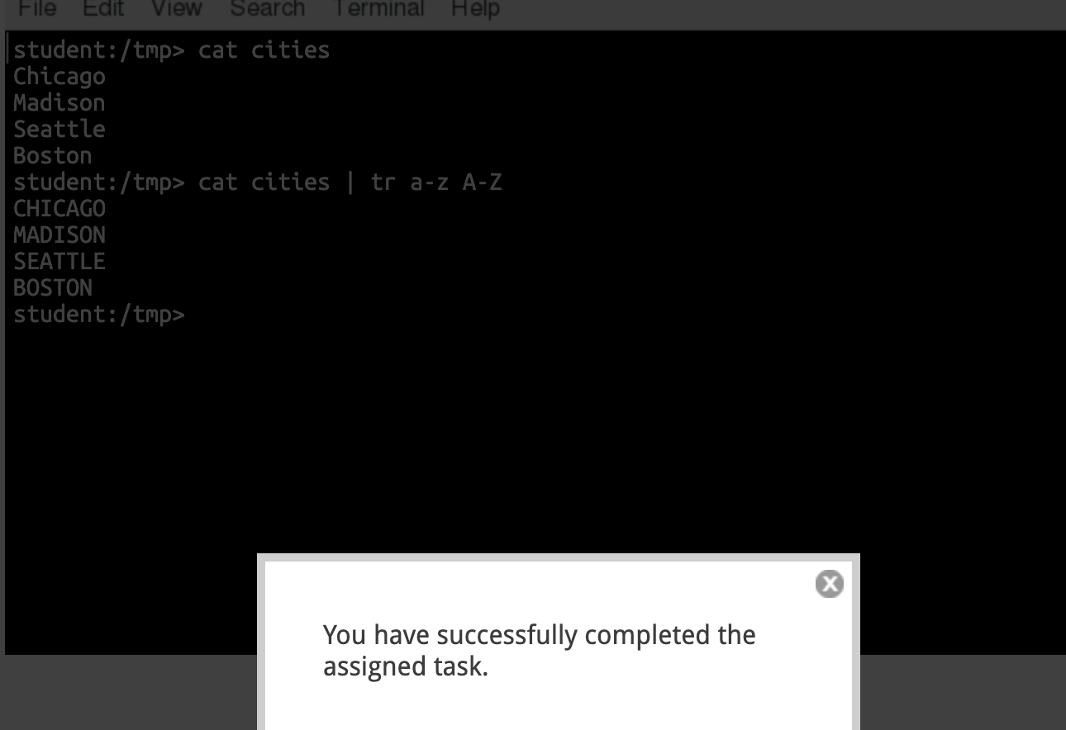
- Extract the first column from /etc/passwd.
